In practice, this isn't difficult to get started on. For a given interface, make a list of all of the types of information on the screen. From that list, ask yourself: Which bit of information here is most important? Do the same thing for all remaining bits of data. Just like that, you've got a logical hierarchy of the data on your page. From a User Experience perspective, that's really step 1. If you're working with a reasonably well-designed bit of interface, this hierarchy should be reflected in the design of the page. It's very likely that the single most important thing on a given screen should be the biggest/boldest thing, and located somewhere near the very top of the content area of the page.

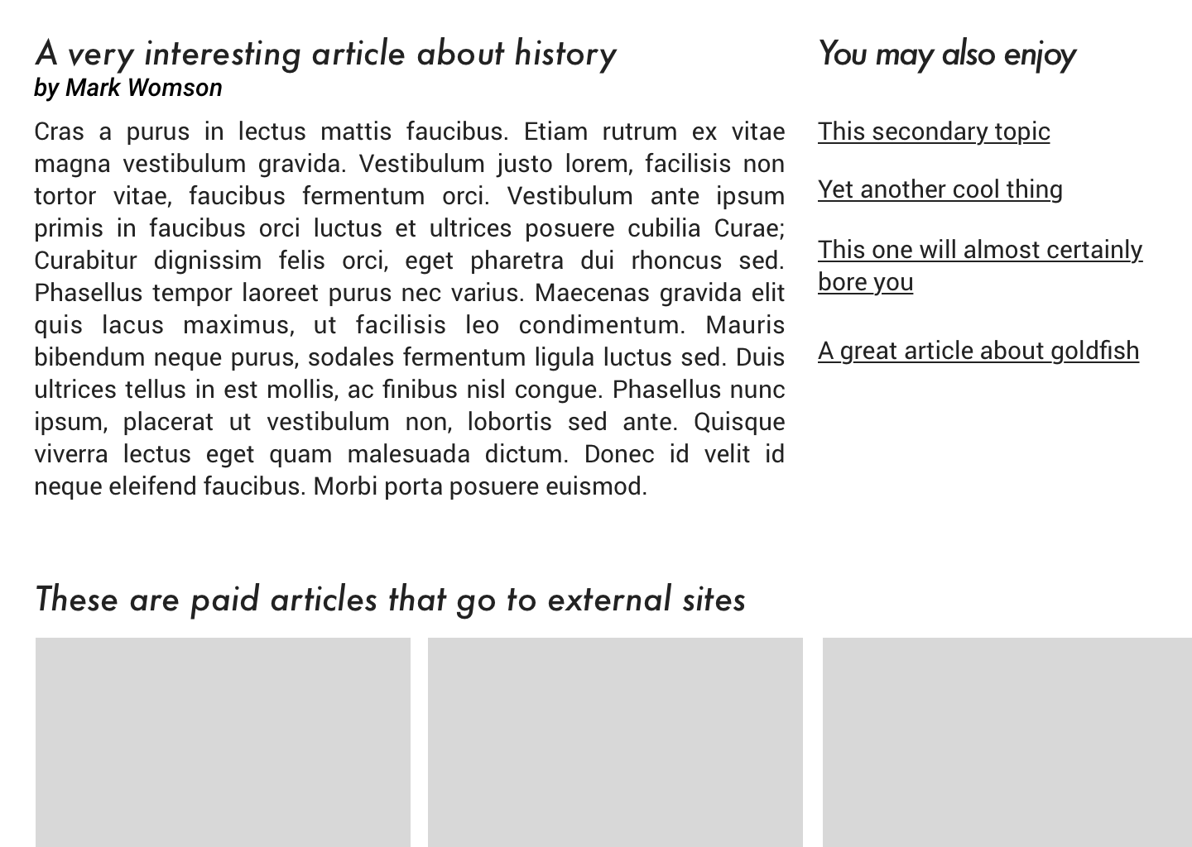
For example, if you are showing a feed of articles, and next to that feed of data are some suggestions for things to read next, and a list of trending articles, then feed is probably the primary data, the suggestions might be secondary, and the service which shares trending articles might be down, so that could be tertiary.

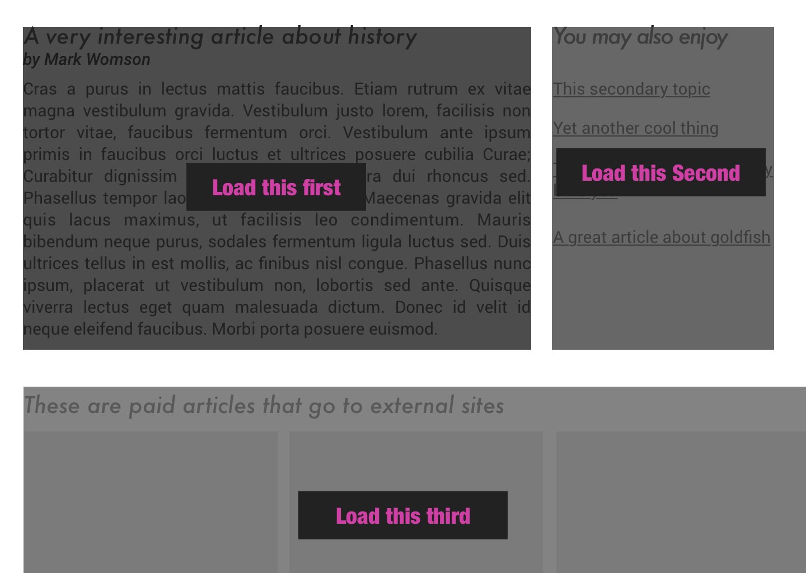
Load the most pertinent content first, and progress from there based on how important it is to your reader.

